

Stoke Minster CE Primary Academy
Admissions Policy
(For Implementation from 1st September 2025)

Stoke Minster CE Primary Academy welcomes children from all backgrounds, faiths and those of no faith and are committed to developing an inclusive school that reflects the diversity of the local community. Admission to the Academy is not dependent on being a member of a particular faith community.

As well as being an inclusive academy, as a Church of England school we have a distinctive ethos and character that reflects the teaching of the Bible and Christian values. All parents applying for a place at our Church of England Academy are asked to respect this ethos and its importance to the school community. It is hoped that all children who attend our Church of England Academy will be able to participate (as appropriate) in the religious life of the school (including collective worship and religious education). This does not affect the right of parents who are not Christian to apply for a place. Indeed, through our commitment to inclusivity, families from other faiths and no faith are warmly welcomed.

Admissions Process
Parents wishing to apply for a place at Stoke Minster CE Primary Academy can apply online at www.stoke.gov.uk/admissions or complete the Admission Application Form, which is available from the academy. This should then be returned directly to the academy or to the Local Authority by the published closing date.

The admission of pupils with a statement of Special Educational Needs/Education Health Care Plan (EHCP) are dealt with by a separate procedure. These children will be admitted to the Academy if our school is named on the statement/EHCP. This is a statutory entitlement under S.324 of the Education Act 1996.

The maximum number of children we can accept into Nursery each year is 39 and Reception each year is 60. If there are more applicants than places available, the Governors, who are the admissions authority for the Academy, will operate the following oversubscription criteria:

- Children in care and children who ceased to be in care because they were adopted (or became subject to a child arrangements order or special guardianship order), including those children who appear (to the admission authority) to have been in state care outside of England and ceased to be in state care as a result of being adopted.

- Children who (at the time of application) have an elder brother or sister in attendance at the Academy and who will still be attending at the proposed admission date.

Siblings are considered to be those children who live at the same address and either:

  - Have one or both natural parents in common
OR
  - Are related by a parent’s marriage or related by parents living as partners at this address
OR
  - Are adopted or fostered by a common parent
OR
  - Children not adopted, fostered or related by a parent’s marriage or with one natural parent in common, who are brought together as a family by a same sex civil partnership and who are living at the same address, are also considered to be siblings.

We do not include cousins within our definition of siblings.

If a child lives with parents with shared responsibilities, each for part of the week, the ‘home address’ will be the one at which the child is resident for the greatest part of the school week. Where this is equally shared, the home address will be the one used when applying for child benefit.

- Children who are baptised members of a Christian Church which in in communion with the Church of England. A copy of the baptismal certificate must be provided at the point of application.

- Other students arranged in order of priority according to how near their home address point is to the Academy. Distance is measured by straight line measurement from the front door of the house to the main gate of the school on Boothen Old Road as measured by the Local Authority geographical information system.

All applications will be ranked against the oversubscription criteria.

Appeals.
Parents who wish to appeal against the Governors' decision not to offer a place to their child, must do so by writing to the Local Education Authority Appeals Committee, Democratic & Committee Support, Democratic Services Division, City Director’s Office, City of Stoke-on-Trent, Civic Centre, Glebe Street, Stoke-on-Trent, ST4 1HH. The Independent Appeals Panel must hear the appeal within 30 school days of its receipt and will notify parents of their decision within 5 working days.

In Year Admissions
Admissions into year groups other than at the normal point of entry will be on an in year transfer application form, directly to the Academy and the allocation of places will be made in line with the above oversubscription criteria.

Waiting List

The Academy will maintain a Waiting List until the end of each academic year. Applications for inclusion on this Waiting List must be made directly to the Academy and these will be ranked according to our over-subscription criteria.

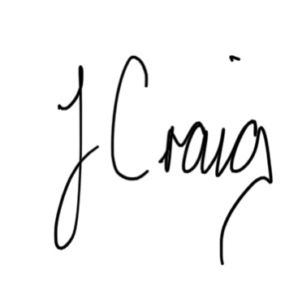
J Craig

Principal
Stoke Minster CE Primary Academy

