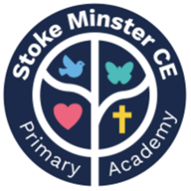
Stoke Minster C E Primary Academy
April 2024 Newsletter

Dear Parents/Carers,
Another month has passed and we have been very busy once again!

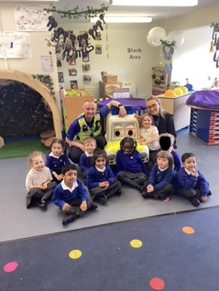

Nursery and Reception enjoyed a visit from PCSO Andy. The children learned about people who keep us safe and they spent time looking at Bobbie the robotic police car!

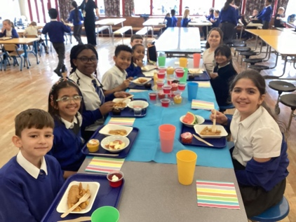

We have introduced a Top Table on Friday lunchtimes. Children across the school who have shown respect, kindness and good manners during lunchtimes are chosen each week are chosen to sit at this special table!



Uniform Expectations:

All children in Y1-6 should be wearing a tie to school. Ties can be purchased through ParentPay.
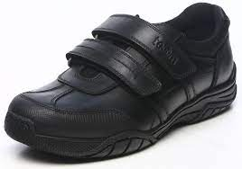
Black school shoes should be worn to school everyday. Trainers are only permitted on PE days.
PE kit is PLAIN black joggers or shorts and hoody and a PLAIN white t shirt.


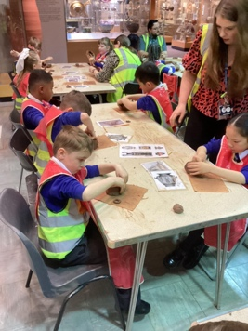

Year 3 enjoyed a trip to the Potteries museum linked to their learning on Ancient Greeks.
They had lots of fun making clay pots and exploring the exhibits.
In school, children can earn values Points when they follow school rules linked to our values. Here are some of the things the children can do to earn a Values Point. Once they earn 50 points for any value, they will receive a special badge that they can wear on their uniform.

  Love | Hope
Be Kind  - Be mindful of others at all times  - Welcome new children  Be Respectful  - Use manners with everyone  - Hold doors open for people  - Treat property in the correct way  Be a good friend  - Don’t leave others on their own – ensuring inclusivity /friendship  - Model how to be a good friend  - Help others | Aspire  - Set goals for yourself and support others to reach their goals  - Actively engage in your leaning  Persevere  - Do your best; give 100% effort  - Manage your own learning – go above and beyond  Have Courage  - Do the right thing even if that is hard  - Try something new
Faith | Flourish
Reflect  - Reflect on your learning in all areas of the curriculum  - Be able to reflect and make positive changes to your behaviour  Forgive  - Show forgiveness and kindness after mistakes  Respect others  - Respecting the faith of others  - Listen respectfully to each other  Follow the behaviour of others  - Think and act in a way that demonstrates our school values | Have Pride  - Correct uniform, organisation and conduct around the school  - Excellent and sustained presentation in all of your work  - Represent the school well  Be Creative  - Be brave in art, creative writing, drama, music – even if it’s not your favourite things!  - Contribute good ideas in your lessons  Risk-Take  - Go above and beyond in lessons  - Push yourself with new

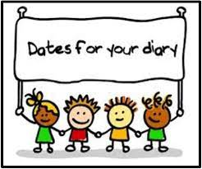
Dates for your diary:
Monday 6th May: Bank Holiday (school closed)
Wednesday 8th May: Y2 trip to Dudley Zoo
Friday 10th May: Y1 trip to New Brighton Beach
Monday 13th May: SATs begin for Y6 pupils
Friday 17th May: Y6 trip to Chester Zoo
Friday 24th May: INSET (school closed to pupils)
Monday 27th May: Half term
Monday 3rd June: School reopens

