
Stoke Minster C E Primary Academy
January 2024 Newsletter

Dear Parents/Carers,
Happy New Year! We were so happy to welcome all of the children back after the Christmas holidays- it actually feels like we’ve been back for much longer than only a few weeks!

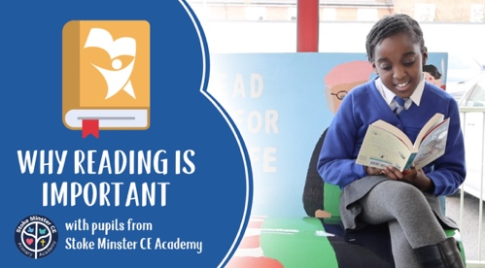

If you haven’t already, then do check out our video to promote reading. Isabella, Angel, Jake and Frankie had such fun being involved in this and we are so proud of the result.
You can find the video on Dojo or our school Facebook page. Give us a follow if you don’t already!

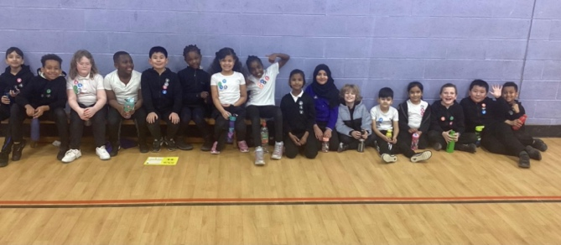
Mr Locker has been very excited since the arrival of our minibuses as he is now able to start taking children out to sporting competitions!
The first group were from Y3 and Y4 and they attended an event at Trentham High School. They were an absolute credit to us, behaving brilliantly and trying their hardest. Well done everyone!


We will be saying a fond farewell to Miss Morris at the end of this week. As you know, Miss Morris is a much valued member of our office team and we will all miss her very much!
She is relocating down to London and we wish her all the best for the future. Stay in touch Miss Morris!

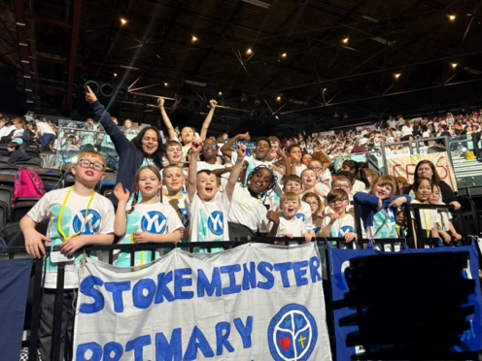

Our choir attended the Young Voices event in Birmingham last week. They had a fantastic time singing in a choir of 5472 children!
A huge thank you to the staff and family members who attended and a special thank you to Mrs Peake for all of her hard work!

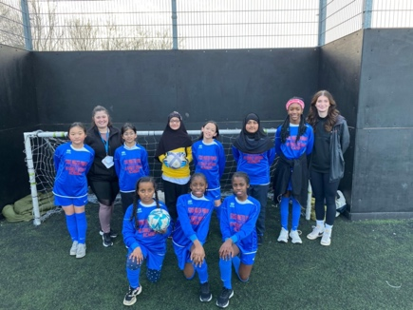
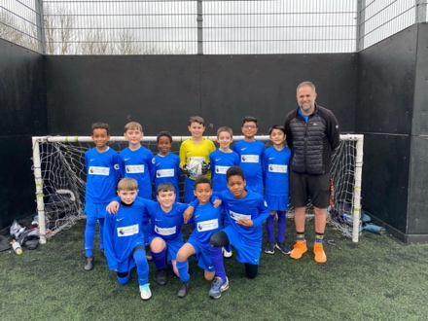

A massive well done to both our boys and girls football teams who each competed in their first matches last week. They performed brilliantly and we are looking forward to the next matches!

If you have any concerns about safeguarding or would just like some support (or even just a chat!):
The Designated Safeguarding Leads in school are Mrs Craig and Mrs Peake. The Deputy Safeguarding Lead is Miss Dance.
Please speak to us if you have any safeguarding concerns relating to a child.

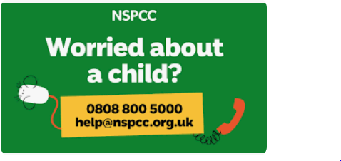
If your concern is urgent or relating to anything that is happening outside of school please contact The Children's Advice and Duty Team (ChAD) on 01782 235100. Outside of office hours you can contact The Emergency Duty Team on 01782 234234.
Of course, if you believe a child to be at immediate risk call 999.

The NSPCC can also be a great source of information and they can also be contacted for help and advice on 0800 800 5000 or via their website: www.nspcc.org.uk


Just a reminder about school uniform:

Children should not be wearing trainers unless it is their PE day.
PE kit is PLAIN black joggers and a PLAIN black hoody with a PLAIN white t shirt.

All children in Y1-6 should wear a tie.

If you require any uniform, please let us know. We have lots of donated items to share with you.

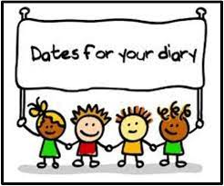
Dates for your diary:
Monday 12th February: Half term
Monday 19th February: Children return to school
Thursday 22nd February: No Little Minsters or after school clubs due to staff training

