
Stoke Minster C E Primary Academy
July 2024 Newsletter

Dear Parents/Carers,
Wow! What a year! I cannot believe that I am writing to you at the end of the summer term- this year has flown. We have had a fantastic year with lots to celebrate: the arrival of our minibuses, sports team achievements, class trips, the swimming pool, the children making fantastic progress in class… the list goes on! We hope that you have a lovely summer holiday and look forward to seeing you all in September!

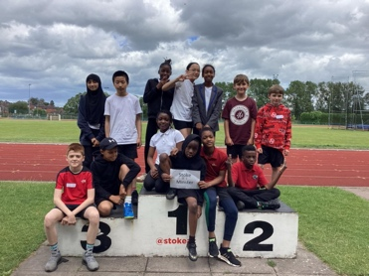
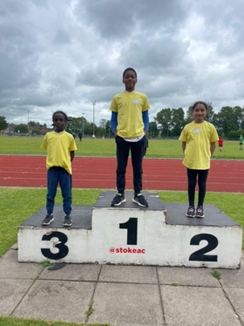
Children across KS2 represented the school at Northwood for the city trials. They showed resilience, perseverance and a great sporting attitude!
Emmanuel, Aamina and Rayan qualified to return to compete in sprint, javelin and relay. Well done everyone!


Mrs Dibden will be leaving us at the end of this week. Mrs Dibden came to work with us on a seconded post from another school in the St Bart’s trust. She has worked in Year 2 and Reception this year and has been as asset to our team.
We wish you all the best Mrs Dibden and will miss you!

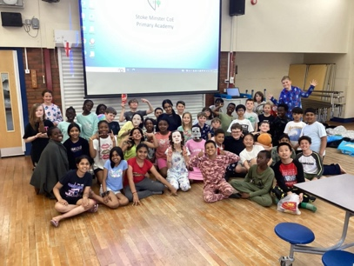
We say a sad goodbye to our Y6 children this week. They have been an amazing group of children and will be greatly missed. We wish them all the best as they move on to the next chapter of their education.
Stay in touch Y6- we’d love to hear about how you are getting on!



Miss Wemyss gets married over the summer holidays. When we return in September, she will be Mrs Best.
Congratulations Miss Wemyss- we hope you have an amazing wedding day!

***LITTLE MINSTERS***

Little Minsters is a paid care club after school that is open until 5.15pm. Please note the arrangements for booking into Little Minsters:
- Contact Miss Lanaghan through dojo to confirm a place. (You will need to join the Little Minsters Dojo group; ask your child’s class teacher or Miss Khan if you would like to join.)
- Pay for the dates you have booked through ParentPay. All sessions must be paid for in advance.



Uniform Expectations:
Please not expectations for September:
All children in Y1-6 should be wearing a tie to school. Ties can be purchased through ParentPay.
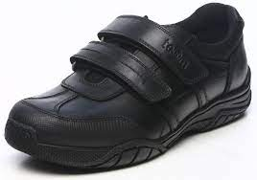
Black school shoes should be worn to school everyday. Trainers are only permitted on PE days.
PE kit is PLAIN black joggers or shorts and hoody and a PLAIN white t shirt.
Please label all uniform so that it can be reunited with its owner- this is especially important for ties and jumpers!
School jumpers and cardigans are available to order through ParentPay and can be collected at the school office.

If you need any support with uniform, please speak to Mrs Dance or Miss Edwards.

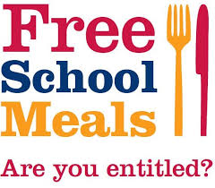
All children in Reception, Y1 and Y2 are entitled to universal free school meals regardless of income.
Children moving in Nursery, Y3, Y4 , Y5 and Y6 need to pay for school meals (£2.60 per day) unless they are entitled to free school meals.
If you are eligible for free school meals (or think that you might be) please speak to Miss Khan in the school office or apply on our website.

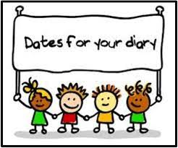
Dates for your diary:
Friday 19th July: Last day at school
Wednesday 4th September: Children return to school

