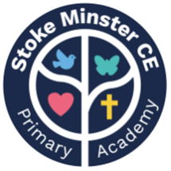
Stoke Minster C E Primary Academy
March 2024 Newsletter

Dear Parents/Carers,
We’ve reached the end of another busy term. Have a fantastic break and Happy Easter!

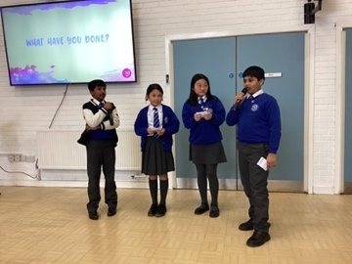
Our school Chaplains joined other schools from across the St Bart's trust for some training and networking this term. They shared the great work they have been doing and the plans they have moving forward. They spoke beautifully in front of the other children and represented our school perfectly. Well done!

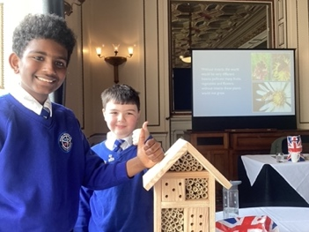
Our sustainability council representatives met at Keele university this term to discuss biodiversity. They made a bee hotel for solitary bees which we will place in one of our flower beds. They spoke eloquently about the fine work being done in school and took ideas away that they heard from others. They represented themselves and the school fantastically.



We say goodbye to Miss Thorley at the end of this week. Miss Thorley came to work with us last year in Reception and she will be greatly missed! We wish you all the best at your new school Miss Thorley!

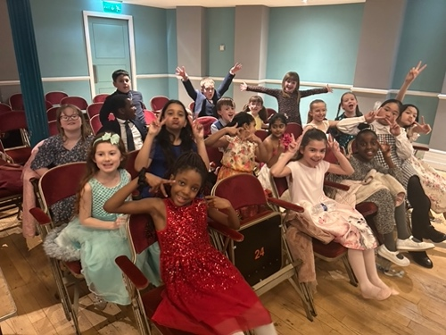
Huge congratulations to our fantastic dancers who performed at the Victoria Hall earlier this week. They worked so hard in preparation for this event and represented the school beautifully!
A special thank you to Miss Wemyss, Mrs Hepple and Mrs Bradbury for choreographing the dance and spending hours on rehearsals.
Well done everyone!

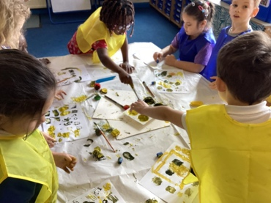

We had a fantastic time during our whole school art day where each class created art work for our school values displays. Thank you to artist, Kate Windsor, who came to work with us!



As Eid will fall before our next newsletter, we would like to wish all of our Muslim families a blessed Eid!
Eid Mubarak!



We raised £??????? For Comic Relief! Thank you all for your kindness and generosity!



After Easter, there will an increase in the cost of school meals from £2.40 - £2.60 per day (£2.30 per day for nursery.)
We have not increased the price of our school meals for a long time, but sadly, due to increased food costs, we are unable to continue at the current price.
The new price still represents excellent value for money and is far cheaper than the majority of primary schools in Stoke on Trent.
Please speak to Miss Khan in the office if you think that you may be entitled to free school meals. Thank you!

Dates for your diary:
Friday 22nd March: Church service at Stoke minster Church 9.30am
Friday 22nd March: Parents/ carers invited in to complete Easter crafts with the children 1.45pm (last day at school)
Monday 8th April: Return to school
Monday 8th April: SATS meeting 2.45pm (for Y6 parents)

