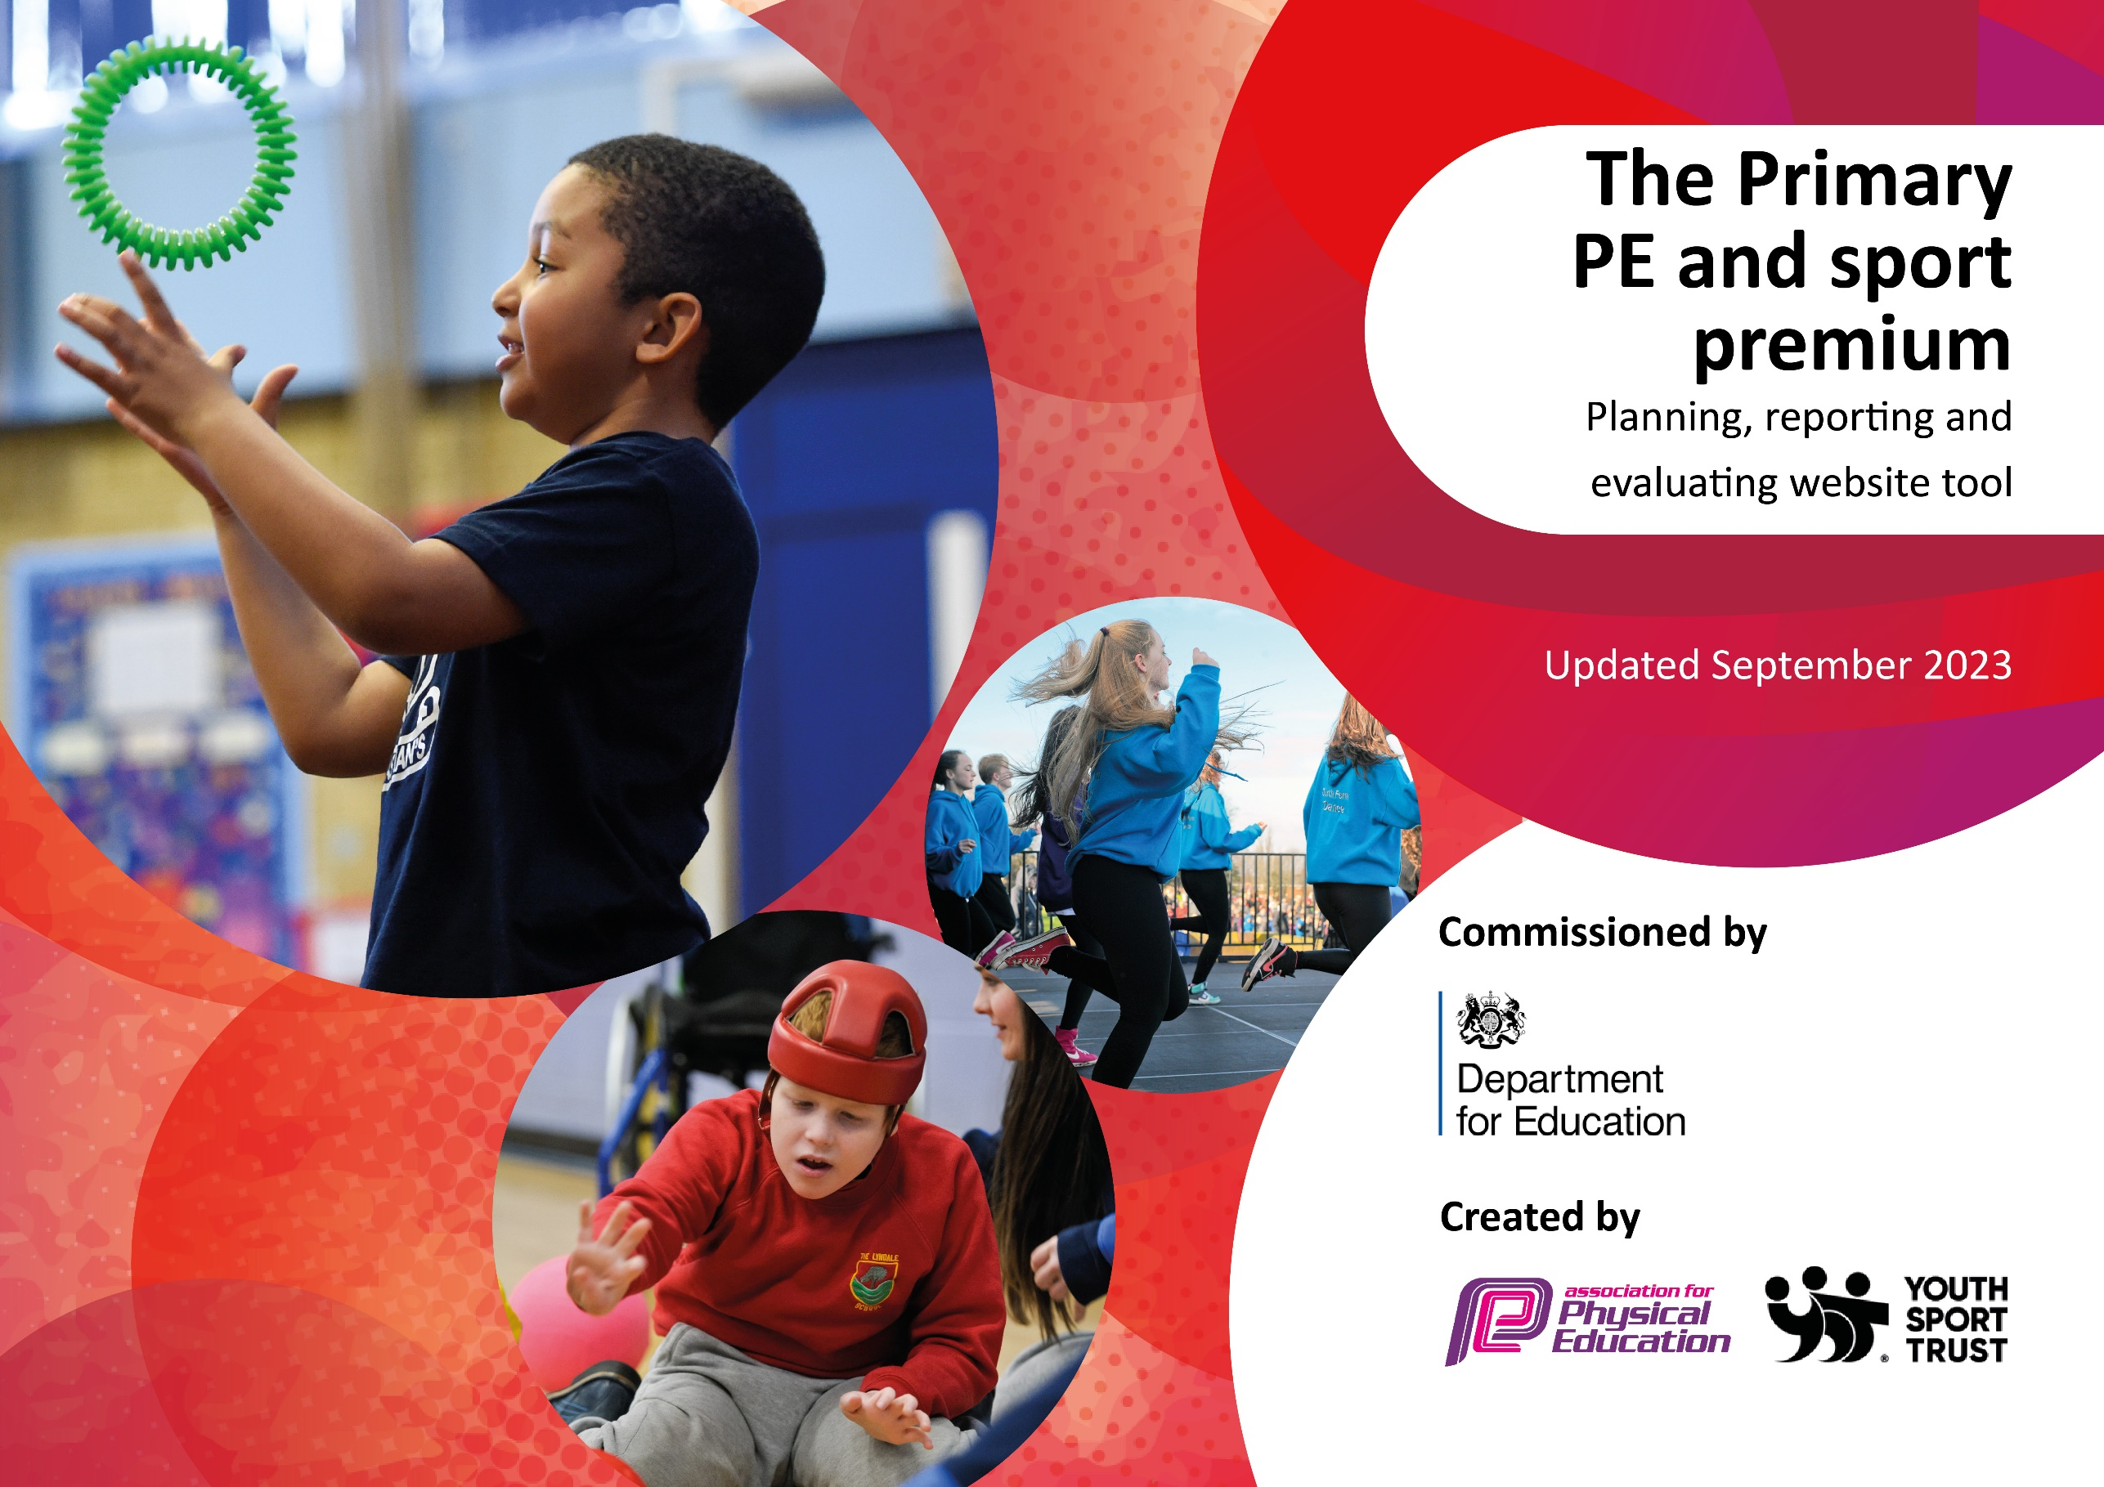

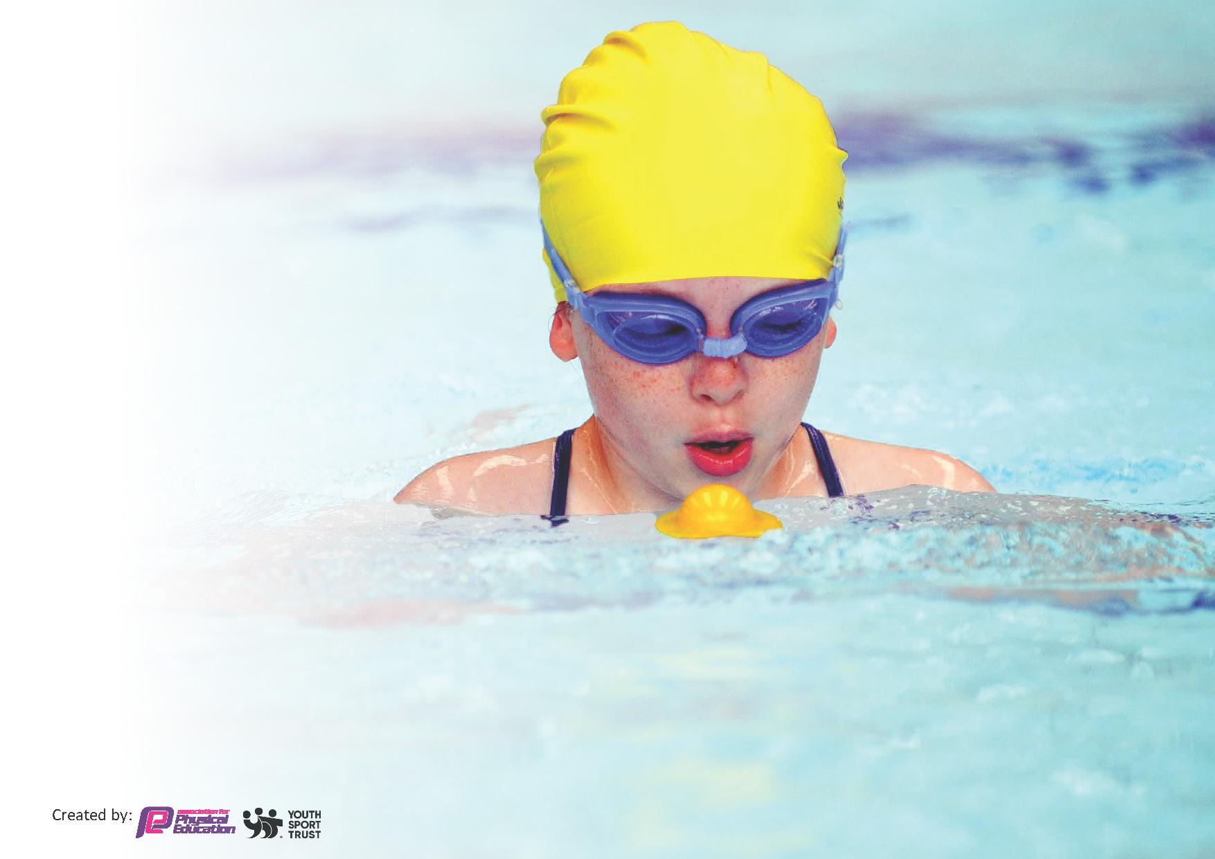
This template can be used for multiple purposes:
by:
- It enables schools to effectively plan their use of the Primary PE and sport premium
- It helps schools to meet the requirements (as set out in guidance) to publish information on their Primary PE and sport premium
- It will be an effective document to support Ofsted inspections enabling schools to evidence progress in Physical Education (PE) and evidence swimming attainment, which forms part of the PE National Curriculum. We would recommend schools consider
the Intent, Implementation and Impact of any spend, as examined within the Education Inspection Framework.

It is important that your grant is used effectively and based on school need.

Schools must use the funding to make additional and sustainable
improvements to the quality of the PE, School Sport and Physical Activity (PESSPA)
they offer. This means that you should use the Primary PE and sport premium to:

- Build capacity and capability within the school to ensure that improvements made now will benefit pupils joining the school in future years
- Develop or add to the PESSPA activities that your school already offers.

The Primary PE and sport premium should not be used to fund capital spend projects; the school’s core budget should fund these. Further detail on capital expenditure can be found in the updated Primary PE and sport premium guidance.

The Primary PE and sport premium guidance, outlines 5 key priorities that funding should be used towards. It is not

necessary that spending has to meet all the key priorities, you should select the priorities that you aim to use any funding towards.

Although completing this template is not a requirement for schools, schools are required to publish details of how they spend this funding. Schools must also outline what the impact this funding has had on pupils’ PE and sport participation and attainment and how any spending will be sustainable in the future. All funding must be spent by 31st July 2024.

The Department for Education has worked closely with the Association for Physical Education (afPE) and the Youth Sport Trust (YST) to develop this template and encourages schools to use it. This template is an effective way of meeting the reporting requirements of the Primary PE and sport premium.
Review of last year’s spend and key achievements (2024/2025)

We recommend you start by reflecting on the impact of current provision and reviewing your previous spend.

Activity/Action | Impact | Comments
PE Curriculum & improving the quality of teaching and learning.  Raising the profile of health & wellbeing and the development of life skills.  Expanding opportunities for competition | Through the delivery of well-planned lessons and high quality teaching pupils have continued to make good progress in lessons and have develop their skills to a good level.  Pupils feedback on their enjoyment and engagement in lessons and this continues to grow so that all pupils have positive experiences, improved self esteem, knowledge of the importance of being active and staying healthy and a love of PE.  School, PE leader, PE champions team and the rest of the staff remain up to date with latest guidance and best practice in the subject through sharing ideas and this ensure the best possible impact and outcomes for pupils.  Staff feel confident in using a range of resources and strategies to promote pupils physical and emotional health and well-being.  These are used when needed within lessons at lunchtime and sent home as activities. Pupils feel confident is using these strategies to them to help them deal with emotional situations they may be experiencing..  Through participation in regular outdoor learning and forest school activities pupils will develope a love of the outdoors and nature and are developing their life skills including trust, respect, teamwork and communication.  Calendar of competitions clearly mapped out and fits well to current curriculum overview and extra curricular clubs on offer for pupils  Staff offering pupils opportunities to be competitive or take part in performances at the end of the unit of work.  Pupils taking part in my personal best challenges which motivate and engage them and give them increased confidence and self-esteem in their abilities.  Parents involved in supporting PE, sport and health offer for pupils and everyone being more active together and taking part in opportunities available.

Key priorities and Planning
This planning template will allow schools to accurately plan their spending.

Action – what are you planning to do | Who does this action impact? | Key indicator to meet | Impacts and how sustainability will be achieved? | Cost linked to the action
Increase physical activity outside of PE lessons. | - Playground leaders  - Lunchtime supervisors  - Sport coaches  - PE lead  - Teaching staff  - Pupils | Key indicator 2 -The engagement of all pupils in regular physical activity – the Chief Medical Officer guidelines recommend that all children and young people aged 5 to 18 engage in at least 60 minutes of physical activity per day, of which 30 minutes should be in school.  Key indicator 4: Broader experience of a range of sports and activities offered to all pupils.  19130 | More pupils meeting their daily physical activity goal, more pupils encouraged to take part in PE and Sport Activities. | £4000 to cover cost of sports coaches running lunchtime and after school clubs.

To offer children the opportunity to experience a wide variety of sport and physical activity  Actively seek opportunities for all children (SEN/PP/EAL) to participate in competitive sport | - Pupils taking part  - PE lead  - Teachers  - Sports coaches | Key indicator 5: Increased participation in competitive sport. | - Dance Shows (Victoria Hall)  - Staffs lifting club  - New extra curricular opportunities - Links to local clubs  - Trust collaboration and competitions  - Visits  - Professional clubs and sporting events  - Time4Swimming Pool to School  - Attend school games events across the city - Develop the enrichment planner - Continue to attend competitions - Participate in Trust events  - - Intra house competition - Resources to lead intra house competitions | £9130  £1000
To provide high quality CPD to all staff to enable them to deliver HQT in PE. | - Teachers  - Support staff  - PE lead  - Pupils | Key indicator 1: Increased confidence, knowledge and skills of all staff in teaching PE and sport  Key Indicator 3: Profile of PE and sport is raised across the school as a tool for whole-school improvement | - Whole school CPD  - PE team CPD - Achieving AfPE accreditation mark - Acheive school games award  - - Up skilling staff to build sport journalists across KS2  - - Sports Journalist pupil leadership - Subject leader feedback and learning reviews | £5000

Key achievements 2023-2024
This template will be completed at the end of the academic year and will showcase the key achievements schools have made with their Primary PE and sport premium spending.

Activity/Action | Impact | Comments
Children now travel to competitions via minibus  Competed at a variety of sports at different age groups  Success at level 2 and some level 3 competition  Children have been on physically active programs  Staffing structure and time given  Girls’ clubs are run alongside boys’ clubs  From September, there should be a field to the rear of the School to increase space for PE lessons.  The use of Staffs Lifting Gym throughout the school day and after school use  Back in December there was an Olympic athletes day in school. | Children are now performing at level 2 in competition outside of school.  Children understand that to represent Stoke Minster CE Primary Academy, the standards that they set inside of school impact on their eligibility to compete (behaviour and work)  Children have achieved personal goals and represented the school in a physical activity. This has promoted their sense of worth and understanding of winning and losing.  We have compoeted in a variety of different sports with children competing at varying levels.  There have been times where we have won and been successful which the children have not experienced before. This has raised the aspirations of our children. Some have gone on to represent their town in city events.  Children with SEND have been given the opportunity to go to Staffs Gym to take part in activities that test the resolve and attitude of the children. To attend, they have to demonstrate positive behaviour within the school setting. The children have shown great effort and commitment.  Time has been given for staff to take children out to competitions during school time. The principal and SLT have been pro active in their encouragement of all sports and trips during school time and after school.  Girls have been just as successful as the boys, with opportunities for them to compete and train. Girls have competed in football, cricket and athletics and have done very well.  Work is being completed to transform the back of the school into a field which the children and staff can use. Hopefully from September we will be able to use the field to help progress Physical Education at Stoke Minster.  Children have been attending the gym throughout the year. These visits have been available to children across the school including those with SEND.  These visits have been a great incentive for some children who sometimes struggle to behave in a positive way and there has been an improvement in their attitude in school.  On this day, four athletes who were to attend the Paris Olympics 2024 came into the school and worked alongside the children. During the day, the children were off timetable and performed many different activities, from archery and sprinting to ping-pong challenges with a cup.  All of the children were involved from Nursery up to Year Six and the athletes and the children had a superb day.  One of the athletes, Ashely Nelson, was from our local area and the children found this very inspiring.  The athletes showed and spoke about how to persevere and show resilience to achieve what might be thought of as an impossible dream.

Swimming Data
Meeting National Curriculum requirements for swimming and water safety.
Priority should always be given to ensuring that pupils can perform safe self-rescue even if they do not fully meet the first two requirements of the National Curriculum programme of study

Question | Stats: | Further context  Relative to local challenges
The percentage of pupils in Year 6 who can perform safe self-rescue in different water-based situations | 76%
What percentage of your current Year 6 cohort can swim competently, confidently and proficiently over a distance of at least 25 metres? | 47% | We had a pool on site that Time 4 Sport use. Their coaches deliver lessons for all of our children from nursery all the way up to year 6.  In spring 1 and spring 2, Year 6 completed a swimming course. This percentage of children represents the amount of children that were competent in the water.  .
What percentage of your current Year 6 cohort can use a range of strokes effectively [for example, front crawl, backstroke, and breaststroke]? | 33%
Have you provided CPD to improve the knowledge and confidence of staff to be able to teach swimming and water safety? | No | We are a Primary Academy which relies on an outside company teaching swimming to our children. For that reason, there is no need for our staff to teach swimming and water safety.

Signed off by:

Head Teacher: | Jennifer Craig
Subject Leader or the individual responsible for the Primary PE and sport premium: | Nick Locker
Governor: | Ian Hunt (Chair of IMB)
Date:

